Geometry Honors Ch 3 CW WS
DO NOT MARK THIS SHEET
DO ALL WORK AND DRAW ALL DIAGRAMS ON YOUR OWN PAPER

- Find the equation of the perpendicular bisector of the segment with endpoints of (4, 9) and ( 10, -1).

- Find the equation of the line with an x intercept of –3 and y intercept of 2.

- Find the value of a so that 6x + ay = 10 is perpendicular to y = (4/3)x + 2.

- Let A(4, 2), B(–4, –2), and C(x, y) be three points in the coordinate plane.
  - Find the slopes of AC and BC .
  - Suppose ^{AC} ⊥ ^{BC} Write and simplify an equation involving x and y.

  - Describe the set of points C such that AC ⊥ BC .

- A line passes through the points (3k, 6k −5) and (−1, −7) and has y-intercept of −5. Find the value of k and the equation of the line.

- If UV , WX , and YZ are all parallel, find the measure of each angle in terms of x and y

  - ∠ VXW b. ∠ WXZ c. ∠ VXZ

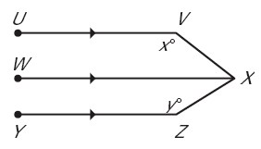

- Find x and y such that p ║ q, q ║ r, and p ║ r.

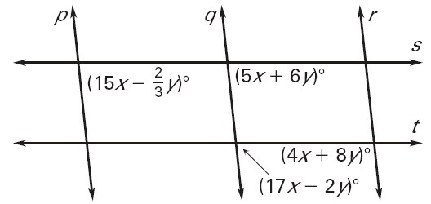

8.
m∠ FED = m∠ GCA = 45°

GIVEN: CA   ED

PROVE: EF CG

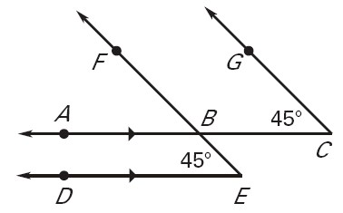
- In the diagram, m || n. Find the value of x.
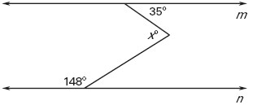
Explain how you obtained your answer.

- GIVEN: g || h, ∠1 and ∠2 are supplementary PROVE: p || r

