Statistics, Day 6

Objectives: To solve problems with normally distributed data

Many data sets have a symmetric distribution with one peak. If you have a lot of data and use very small intervals, the histogram becomes a continuous bell-shaped curve, called a normal distribution.

Normal distributions occur quite frequently. Standardized test scores and population heights can both be represented by normal distributions. In both cases, you must have a large number of data points before the distribution looks normal.
In ALL normal distributions, about
*68% of the data fall within one standard deviation of the mean
*95% of the data are within two standard deviations of the mean
*99.7% of the data are within three standard deviations

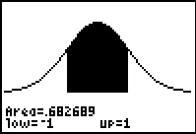
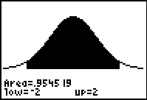
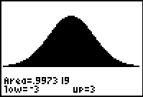

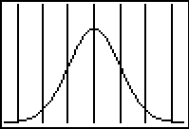

-3 -2 -1 0 1 2 3

Example: The math scores on the SAT are approximately normally distributed with a mean of 500 and a standard deviation of 100. What percent of students score

a) between 400 and 600?
b) between 500 and 700?
c) greater than 700?
d) less than 600?

Example: The amount of coffee dispensed from a vending machine is normally distributed with a mean of 10.50 oz. and a standard deviation of 0.75 oz.

a) 68% of the amount of coffee dispensed falls within what range?
b) About what percent of the time will the machine overfill a 12 oz cup?

Example: The useful life of a tire is normally distributed with a mean of 30,000 miles and a standard deviation of 5000 miles. A company manufactures 10,000 tires a month.

a) Draw the normal curve and label the mean, and + 1, 2, 3 standard deviations from the mean.

a) How many tires will last between 25,000 and 35,000 miles?

b) How many tires will last more than 40,000 miles?

c) How many tires will last less than 20,000 miles?

