**Algebra 2CP: Law of Sines/Law of Cosines Worksheet** Name ________________________________

1. Two airplanes leave Berlin, one heading straight for London and the other



straight for Paris. Use the Law of Cosines to estimate the measure of

the angle, θ, they will form.

2. Find *BC* 3. Find PA 4. Find the length of side b



 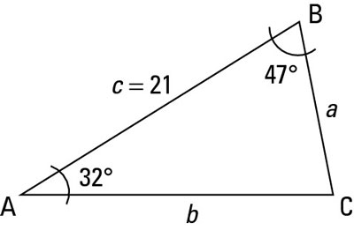

5. Find m∠*S,* m∠*T*, and m∠*U* 6. Find *n*

 

7. Some students in Geometry are assigned the task of measuring the   
 distance between two trees separated by a swamp. The students determine   
 that the angle formed by tree *A*, a dry point *C*, and tree *B* is 27°. They also   
 know that m∠*ABC* is 85°. If *AC* is 150 ft, how far apart are the trees?



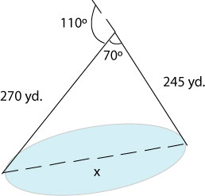8. A surveyor starts at one end of the lake and walks 245 yards. He then turns 110º and walks 270 yards until he arrives at the other end of the lake. Approximately how long is the lake?

9. Find *BC* 10. Find *DE* 11. Find *NO*







12. Find *GH* 13. Find the length of the 14. Find *TU*  shortest side.





