2CP Lesson: Operations with Functions

Core Concepts

Operations on Functions

Let *f* and *g* be any two functions. A new function can be defined by performing any of the four basic operations on *f* and *g*.

|  |  |  |
| --- | --- | --- |
| Operation | Definition | Example: |
| Addition |  |  |
| Subtraction |  |  |
| Multiplication |  |  |
| Division |  |  |

The domains of the sum, difference, product, and quotient functions consist of the *x*-values that are in the domains of both *f* and *g*. Additionally, the domain of the quotient does not include *x*-values for which 

Let’s Try:

In Exercises 1–2, find  and state the domain of each. Then evaluate  for the given value of *x.*

1. 

2.

In Exercises 3-4, find and  and state the domain of each. Then evaluate *fg* and  for the given value of *x.*

3.

4. 

**In Exercise 5, find $\left(2f+g\right)\left(x\right)and \left(-f-g\right)\left(3\right), given f\left(x\right)=2x-1 and g\left(x\right)=5x$**

|  |  |  |
| --- | --- | --- |
| x | f(x) | g(x) |
| -3 | 2 | -3 |
| 1 | 1 | 2 |
| 0 | 5 | 5 |
| 5 | 7 | 6 |
| 9 | 4 | -1 |

**In Exercises 6, use the table to state the domain of f(x) and g(x). Then find the following:**

$\left(f+g\right)\left(1\right)$

$\left(fg\right)\left(1\right)$

$\left(\frac{f}{g}\right)(0)$

$f\left(5\right)-g(9)$

$(2g+f)(-3)$

**In Exercise 7, use the graph to state the domain of f(x) and g(x). Then find the following:**

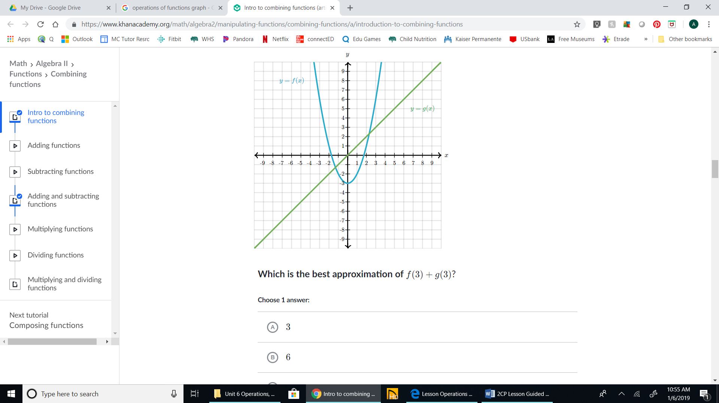

$\left(f+g\right)\left(1\right)$

$\left(fg\right)\left(1\right)$

$\left(\frac{f}{g}\right)(0)$

4. d. $f\left(5\right)-g(9)$
5. e. $(2g+f)(-3)$

**Apply Operations with Functions** Operations with functions can apply to real-world situations.

**Example:** **The players on a basketball team participated in a fundraiser and raised $580 to help pay for shoes for each team member. The shoes cost $100 each, and there is a shipping and handling fee of $50 on each order. Sales tax of 6% is charged on the entire bill. The team member that raised the most money in the fundraiser does not have to pay for her shoes. The remaining players will split the remaining cost evenly. Write a function *C*(*x*) that represents the total cost of the order, where *x* is the number of team members. Write a function *R*(*x*) that represents the cost remaining and *N*(*x*) that represents the number of team members who pay for shoes. Then find $\left(\frac{R}{N}\right)$ (*x*) and explain what this function represents. Finally, if there are 11 members on the basketball team, how much does each of the paying members pay for shoes?**

Find *C*(*x*).

Find *R*(*x*).

Find *N*(*x*).

Find $\left(\frac{R}{N}\right)$ (*x*).

This function represents:

Evaluate $\left(\frac{R}{N}\right)$ (*x*) when *x* = 11.

Each paying member will pay ___________ for shoes.

**Example: For a given triangle, the length of the base is represented by $b\left(x\right)=2x+1$ and the height is represented by $h\left(x\right)=5x$. Write a function A(x) for the area of the triangle.**