2CP HW Practice: Operations of Functions
Let f(x) = 2x + 1 and g(x) = x – 3. State the domain if there are any restrictions.
1. Find (f + g)(x). 2. Find (f – g)(x).

3. Find (f ⋅g)(x). 4. Find $\left(\frac{f}{g}\right)$(x).

Let f(x) = 8$x^{2}$ and g(x) = $\frac{1}{x^{2}}$. State the domain if there are any restrictions.
5. Find (f + g)(x). 6. Find (f – g)(x).

7. Find (f ⋅g)(x). 8. Find $\left(\frac{f}{g}\right)$(x).

Let f(x) = $x^{2}$ + 7x + 12 and g(x) = $x^{2}$ – 9. State the domain if there are any restrictions.
9. Find (f + g)(x). 10. Find (2f – 3g)(x).

11. Find (f ⋅g)(x). 12. Find $\left(\frac{f}{g}\right)$(-2).

13. Use the table to state the domain of f(x) and g(x). Then find the following:
x | f(x) | g(x)
-2 | 5 | -21
-1 | 6 | -14
0 | 7 | -7
1 | 8 | 0
2 | 9 | 7
- $\left(f+g\right)\left(1\right)$
- $\left(\frac{f}{g}\right)(0)$
- $\left(\frac{f}{g}\right)(1)$
- $f\left(-2\right)-g(2)$
- $(2g+f)(-1)$

14. Use the graph to state the domain of f(x) and g(x). Then find the following (estimate where necessary):
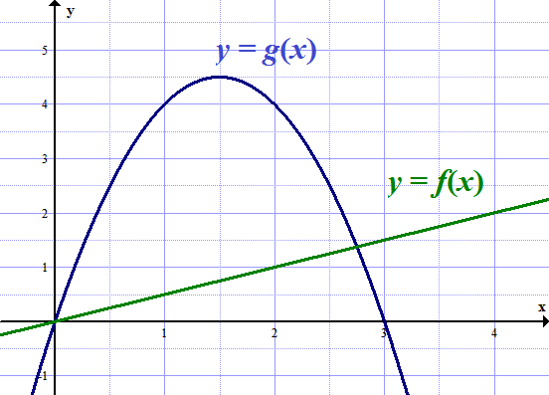
- $\left(f+g\right)\left(1\right)$ c.$f\left(4\right)-g(2)$

- $\left(fg\right)\left(1\right)$ d.$(2g+f)(3)$

15. BUSINESS The function f(x) = 1000 – 0.01$x^{2}$ models the manufacturing cost per item when x items are produced, and g(x) = 150 – 0.001$x^{2}$ models the service cost per item. Write a function C(x) for the total manufacturing and service cost per item.

16. PROFIT The function f(x) = 4$x^{2}$ + 2x represents the revenue a company earns x years after 2000, and g(x) = 10x + 125 represents the cost per year. Write a function P(x) for the profit the company earns per year. (Hint: Profit is the difference of revenue and cost.)

