Algebra 2CP Name _____________________________________

Algebra 2CP S1 Final Exam Information
Multiple Choice, 50 questions, 150 points, Calculator OK
You will take this part in class during regularly scheduled final exams in Jan 2020.

These questions are taken straight from your You Cans, Quizzes, and Tests and modified to accommodate a multiple choice format (with different numbers, of course). To prepare for this portion of the final, you should review all test corrections, quizzes, and You Cans. Refer to previous homework assignments for additional practice.

Algebra 2 CP First Semester Final Practice
Unit 1
1. Describe how the graphs of each of the following functions compare to the graph of the parent function f.
Function | Transformations
$$y=f\left(x\right)+k$$
$$y=f\left(x-h\right)$$
$$y=-f\left(x\right)$$
$$y=af\left(x\right)$$
$$y=f\left(ax\right)$$

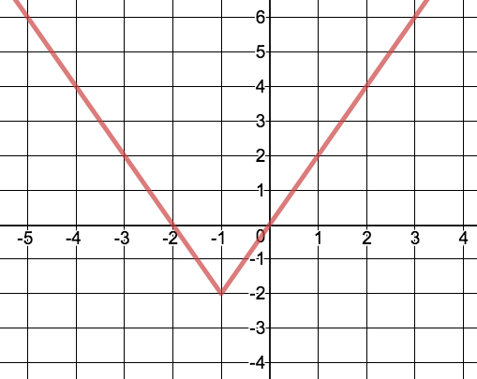

2. Use the graph on the right to answer the following questions:
What is the parent function?____________________________
What is the domain (interval notation):___________________
What is the range (interval notation):__________ ___________
List the transformation(s):________________________________
_____________________________________________________
Write an equation for the graph: ___________________________

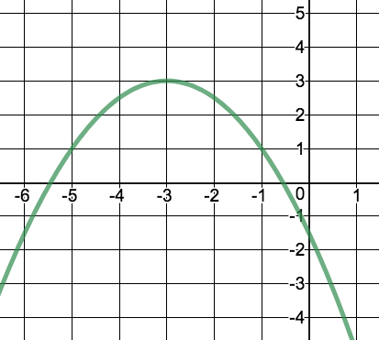

3. Use the graph on the right to answer the following questions:
What is the parent function?____________________________
What is the domain (interval notation):___________________
What is the range (interval notation):_____________________
List the transformation(s):________________________________
_____________________________________________________
Write an equation for the graph: ___________________________

4. $f\left(x\right)={\left(x+3\right)}^{2}+1$ 5. $f\left(x\right)=2\left|x\right|-1$
Axis of Symmetry: Axis of Symmetry:

Transformation(s): Transformation(s):
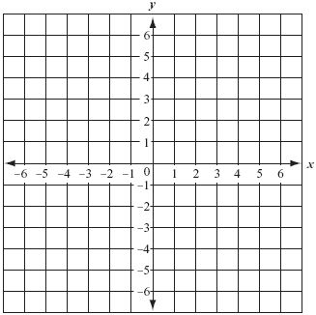
Graph the function: Graph the function:

6. $f\left(x\right)=-2{\left(x+2\right)}^{2}+3$ 7. $f\left(x\right)=\frac{1}{2}\left|x-1\right|$
Axis of Symmetry: Axis of Symmetry:

Transformation(s): Transformation(s):

Graph the function: Graph the function:

For 8-13, graph on the graphing calculator. Describe the transformation(s) and shape of the graph.
8.) $f\left(x\right)=-3x^{2}$ 9.) $f\left(x\right)=\left|x+3\right|-3$ 10.) $f\left(x\right)=\frac{1}{2}\left|x-2\right|$

11.) $f\left(x\right)=-{\left(x-1\right)}^{2}+1$ 12.) $f\left(x\right)=2\left|x\right|$ 13.) $f\left(x\right)=2x^{2}-3$

For 18-19, give the information in the box. To find the equation, show any applicable work. Be sure to use interval notation.
18.)
Transformations:____________________
__________________________________
Equation:__________________________
Domain:___________________________
Range:____________________________
Axis of symmetry:___________________
Intervals of increasing: _______________
Intervals of decreasing: _______________
Maximum: _________________________
Minimum: __________________________

19)
Transformations:____________________
__________________________________
Equation:__________________________
Domain:___________________________
Range:____________________________
Axis of symmetry:___________________
Intervals of increasing: _______________
Intervals of decreasing: _______________
Maximum: _________ Minimum: _____________

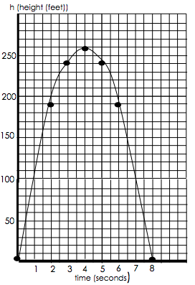
21.) The graph below shows the height h(t) in feet of a small rocket t seconds after it is launched. The path of the rocket is given by the equation: $h\left(t\right)=-16t^{2}+128t$.
a.) What is the vertex? What does it represent in this context?
b.) Using your knowledge of transformations of functions, write the equation for the parabola in vertex form.
c.) What is the interval where the function is increasing? What does this represent in the context of this question?
d.) What is the interval where the function is decreasing? What does this represent in the context of this question?

Unit 2
For 1-4, use the distance formula to come up with the equation of a parabola with the given characteristics.
1.) focus (0,-8) & directrix y=8 2.) focus (5, 0) & vertex (0,0) 3.) directrix y=-3 & vertex (0,0) 4.) directrix y=10 and focus (0, -10)

For 5-8, find the axis of symmetry, focus, directrix, and then graph, using 2 other points besides the vertex.
5.) $y=-\frac{1}{16}x^{2}$ 6.) $x=\frac{1}{24}y^{2}$ 7.) $36y=x^{2}$ 8.) $28x+y^{2}=0$
9.) Given the vertex of a parabola is (0,0) and the equation of the directrix is $y=-3$, find the equation for the parabola and sketch a graph labeling the vertex, directrix, and focus and two other points (1 point on each side of vertex)
10.) Given the vertex of a parabola is (0,0) and the focus is (-4,0), find the equation for the parabola and sketch a graph labeling the vertex, directrix, and focus and two other points (1 point on each side of vertex).
11.) Given the vertex of a parabola is (-3,4) and the focus is (-3,2), find the equation for the parabola and sketch a graph labeling the vertex, directrix, and focus and two other points (1 point on each side of vertex).
12.) Given the focus is (2,4) and the equation of the directrix is $x=4$, find the equation for the parabola and sketch a graph labeling the vertex, directrix, and focus and two other points (1 point on each side of vertex).

14.) Using the graph below, find the vertex, focus, directrix, axis of symmetry, and equation.
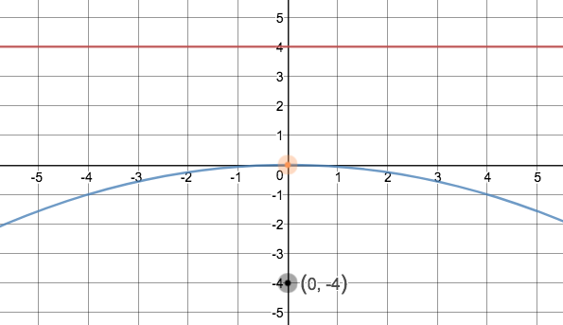

15.) Using the graph below, find the vertex, focus, directrix, axis of symmetry, and equation.
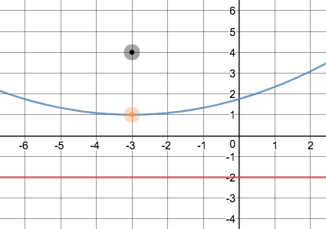
16.) Using the graph below, find the vertex, focus, directrix, axis of symmetry, and equation.
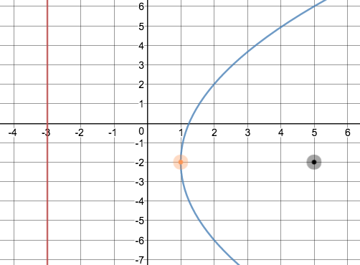
17.) Given $y=-\frac{1}{8}x^{2}$, draw a graph showing the focus, vertex, directrix, and axis of symmetry and 2 other points labeled (1 point on each side of vertex). Label all parts of the graph.

20.) Given $y=-\frac{1}{16}{\left(x-2\right)}^{2}-1$, draw a graph showing the focus, vertex, directrix, and axis of symmetry and 2 other points labeled (1 point on each side of vertex). Label all parts of the graph.

21.) Use the distance formula to write the equation of the parabola below.

23.) An archway in front of the Westlake auditorium is in the shape of a parabola. The top of the arch is the vertex (0,0). The school seal is at the focus, 5 feet below the vertex and the arch is 20 feet wide at the ground. Write an equation that represents a cross section of the arch. What is the height from the top of the arch to the ground?
24.) A parabolic microwave antenna is 16 feet in diameter. Write an equation that represents the cross section of the antenna with its vertex at (0,0) and its focus 10 feet to the right of the vertex. What is the depth of the antenna?

Unit 3
For 1-3, solve by factoring.
1.) $x^{2}+4x=32$ 2.) $2x^{2}+5x-3=0$ 3.) ${4x}^{2}-12x+9=0$
For 4-6, solve using square roots.
4.) $x^{2}=-81$ 5.) ${(x-2)}^{2}+27=0$ 6.) $4x^{2}-31=-111$
For 7-9, solve by completing the square.
7.) $x^{2}-6x+20=0$ 8.) $3x^{2}+12x-15=0$ 9.) $3x\left(x+3\right)=-20$
For 10-19, simplify. Put all answers in standard form.
10.) $\left(3+8i\right)+(4-9i)$ 11.) $\left(3+8i\right)-(4-9i)$ 12.) $(3+8i)(4-9i)$ 13.) $\frac{3+8i}{4-9i}$ 14.) ${(3+8i)}^{2}$
15.) $\sqrt{-25}-\sqrt{-100}+\sqrt{16}$ 16.) $i^{727}$ 17.) $\left(4+8i^{3}\right)-(2+4i^{7})$ 18.) $(3-2i^{12})(4+6i^{9})$ 19.) $\frac{12}{5i}$
Solve by factoring. Solve using square roots. Solve by completing the square.
20.) ${2x}^{2}+5x=12$ 21.) ${2(x+7)}^{2}+56=0$ 22.) $x^{2}-3x+\frac{45}{2}=0$
Simplify. Put all answers in standard form.
23.) $\left(7-3i\right)+(1-2i)$ 24.) $\left(7-3i\right)-(1-2i)$ 25.)$\left(7-3i\right)(1-2i)$ 26.) $\frac{7-3i}{1-2i}$ 27.) ${(7-3i)}^{2}$ 28.) $i^{95}$
Convert from standard to vertex form. Then identify the vertex.
29.) $y=x^{2}-8x+10$ 30.) $y=x^{2}-5x+2$
Solve the system by graphing. Sketch a graph and identify solution(s).
31.) $y=-x+1 y=x^{2}-5$
32.) $y=2x^{2}+3x+4$ $y=x^{2}+2x+3$

Unit 4
For 1-2, divide by factoring first. For 3-4, divide using long division.
1.) $\frac{2x^{2}-5x-12}{2x+3}$ 3.) $(6x^{3}-8x+5)÷(2x-4)$
2.) $\frac{6x^{2}-5x+1}{3x-1}$ 4.) $(x^{3}+9x^{2}+24x+19)÷(x+5)$
F

or 5-6, divide using synthetic division.
5.) $(2x^{3}-3x^{2}+4x+5)÷(x+2)$
6.) $(-2x^{2}+x^{3}-4)÷(x-3)$

7.) For the following function: $f\left(x\right)=-3x^{6}+2x^{5}-x^{3}+4x^{2}-4$

a.) What is the maximum number of real zeros it could have? b.) Is the degree even or odd, c.) Is the leading coefficient positive or negative? Based on your answers from b.) and c.), sketch what the shape of the graph could be?
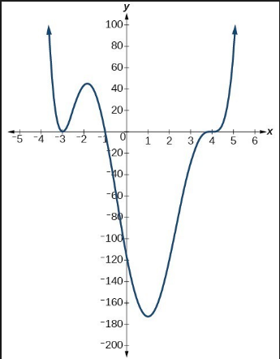
8.) Given the following graph:
a.) Is the degree even or odd? b.)Is leading coefficient positive or negative? c) Describe the end behavior, d.) Domain/range? e.) Absolute min/max f.) Relative min/max, g) Increasing/Decreasing, h.) f(x)>0 & f(x)<0. i.) real zeros

9.) Prove the following polynomial identity: $\left(x^{2}+3\right)\left(x^{2}-3\right)=x^{4}-9$

10.) Sketch the following polynomial, showing the zeros, x-and y-intercepts, end behavior, and general shape.
$f\left(x\right)=x{(x+2)}^{2}(x-3){(x+5)}^{2}$

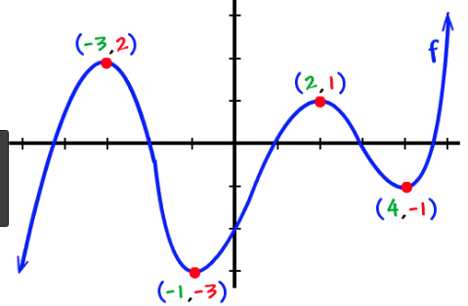
11.) For the following polynomial, find: a.) domain and range, b.) absolute min and max, c.) relative min and max, d.) end behavior, e.) lowest possible degree of the polynomial, f.) positive or negative leading coefficient, g.) interval(s) where the function is increasing and decreasing, h.) interval(s) where $f\left(x\right)>0$ and $f\left(x\right)<0$, and i.) a possible polynomial equation for this graph (use the zeros).

12.) Given $f\left(x\right)=x^{3}-5x^{2}-9x+45$ show that $(x-5)$ is a factor of $f(x)$. Then factor $f\left(x\right)$ completely.

13.) Find all complex solutions, real and imaginary, of $0={4x}^{4}+13x^{2}-12$.

14.) Divide $f\left(x\right)=x^{4}+2x^{2}-x+5$ by $x^{2}-x+1$ using long division.

15.) List all possible rational roots of the function $f\left(x\right)={2x}^{3}+3x^{2}+6x-12$

16.) Find all zeros (real and imaginary) of a polynomial. (Hint: Use your graphing calculator to help you find a real, rational root, then go from there). $f\left(x\right)=x^{3}-3x^{2}+4x-12$

17.) Find all real zeros of $p\left(x\right)=4x^{4}+5x^{3}+2x^{2}-x-6$ in your graphing calculator and tell how many complex zeros there are. Round to 4 decimal places.
18.) The beetle population of a small, remote island can be modeled by the equation
$f\left(t\right)=-0.004t^{5}+75t+1500$ where t is the time in months since observations of the island began, and t=1 represents January.
a. Use your calculator to sketch a graph of the function. Label any intercepts and maxima/minima.
b. During what months was the population increasing? Decreasing? (Use words, not interval notation)
c. During what month did the rabbits have the highest population?
d. What was the highest population?

19.) A farmer has 900 ft of fencing and wants to fence off a rectangular field that borders a straight river. He does not need a fence along the river. What are the dimensions of the field of largest area that he can fence? (see diagram)

X=width | Length | Area
0
100
200
300
400
500
Write equations to model the Length and Area as a function of x. Graph the equation on your calculator. Find the width that will allow the farmer to maximize its area. What is the maximum area?

Length = ___________________ Area = _____________

A width of __________gives a max area of____________.

Unit 5
For 1-3, tell whether x and y show direct variation, inverse variation, or neither. If they are direct or inverse, name the constant of variation (k).
1.) $7xy=4$ 2.) $y=\frac{x}{12}$ 3.) $y=2x+1$
4.) If y varies inversely as x and y = 15 when x = 3, find y when x = 5.
5.) The time it takes you to get to campus varies inversely as your driving speed. Averaging 20 miles per hour in bad traffic, it takes you 1.5 hours to get to campus. How long would the trip take averaging 50 miles per hour?

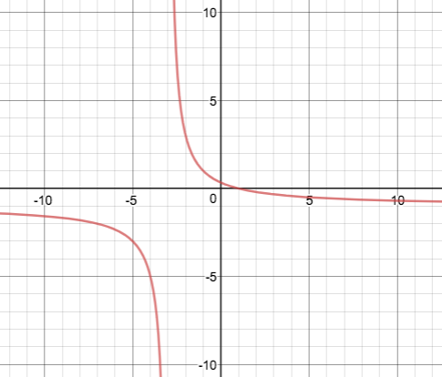
6.) Simplify completely: $\frac{2x^{2}-5x-3}{4x^{2}-8x-5}$
7.) For what value(s) of x is the expression in number 6 undefined? (What can x not equal?)
8.) Simplify completely: $\frac{24x^{4}y^{3}}{9x^{5}y^{8}}÷\frac{48x^{5}y^{2}}{27x^{6}y^{8}}$
9.) Simplify completely: $\frac{x^{2}-x-20}{5x-25}∙\frac{x^{2}-25}{x^{2}+4x-5}$
10.) Simplify completely: $\frac{\frac{3y}{y^{2}-9}}{\frac{6}{y^{2}-6y+9}}$
11.) Simplify completely: $\frac{4}{5x}-\frac{4}{6x}+\frac{3}{10x}$
12.) Simplify completely: $\frac{2x}{x^{2}-x-12}-\frac{3}{x^{2}-5x+4}$
13.) Simplify completely: $\frac{\frac{4}{3x}}{\frac{6}{4x}-2}$
Given the graph to the right, answer the following questions:
14.) Domain (interval notation)
15.) Range (interval notation)
16.) Equation for Vertical Asymptote
17.) Equation for Horizontal Asymptote
18.) Increasing interval(s) (interval notation)
19.) Increasing interval(s) (interval notation)
20.) End behavior

21.) Graph $f\left(x\right)=\frac{1}{x+3}+2$. Draw the asymptotes as dashed lines and label them with their equations.
22.) Graph $f\left(x\right)=\frac{-1}{x-1}+3$. Draw the asymptotes as dashed lines and label them with their equations.
23.) Graph $\left(x\right)=\frac{3x-1}{x+4}$ . Draw the asymptotes as dashed lines and label them with their equations.

24.) Solve: $\frac{4}{x+2}-\frac{1}{6}=\frac{x-1}{x+2}$
25.) Solve: $\frac{4}{x+3}-\frac{7}{x^{2}-9}=\frac{2}{x-3}$
26.) Solve: $\frac{2}{x-3}=\frac{7}{2x-3}$
27.) Mr. Harris can solve the world’s most enjoyable math problem in 4 days. His evil twin brother can solve the same problem in 2 days. How long will it take them to solve the problem if they work together?

