

**Essential Questions**

How can you recognize when two quantities vary directly or inversely?

What are some of the characteristics of the graph of a rational function?

How can you determine the excluded values in a product or quotient of two rational expressions?

How can you determine the domain of the sum or difference of two rational expressions?

How can you solve a rational equation?

**2CP Unit 5 Rational Functions Study Guide**

***Always refer to You Can for complete list of topics on test***

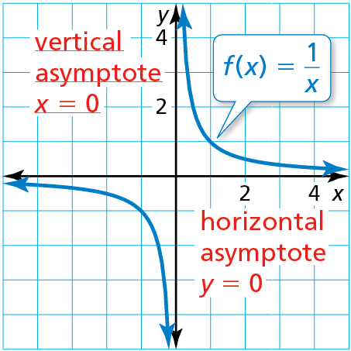

**Parent Function for Simple Rational Functions**

* The graph of the parent function *f*(*x*) = $\frac{1}{x}$ is a *hyperbola*, which consists of two symmetrical parts called branches.
* The domain and range are all nonzero real numbers.
* Any function of the form *g*(*x*) = $\frac{a}{x}$ (*a* ≠ 0) has the same asymptotes, domain, and range as the function *f*(*x*) = $\frac{1}{x}$.

Two variables *x* and *y* show ***inverse variation*** when y = $\frac{a}{x}$, where *a* ≠ 0.

The constant *a* in the inverse variation equation *y = $\frac{a}{x}$,* where *a* ≠ 0 is the ***constant of variation*.**

A ***rational function*** has the form *f*(*x*) = $\frac{p(x)}{q(x)}$, where *p*(*x*) and *q*(*x*) are polynomials and *q*(*x*) ≠ 0.

A ***rational expression*** is a fraction whose numerator and denominator are nonzero polynomials.

A rational expression is in ***simplified form*** when its numerator and denominator have no common factors (other than ±1).

A ***complex fraction*** is a fraction that contains a fraction in its numerator or denominator.

***Cross multiplying*** isa method used to solve a rational equation when each side of the equation is a single rational expression.

**Learning Goals**

Classify direct and inverse variation.

Write inverse variation equations.

Graph simple rational functions.

Translate simple rational functions.

Graph other rational functions.

Simplify rational expressions.

Multiply rational expressions.

Divide rational expressions.

Add or subtract rational expressions.

Rewrite rational expressions and graph the related function.

Simplify complex fractions.

Solve rational equations by cross multiplying.

Solve rational equations by using the least common denominator.

Use inverses of functions.

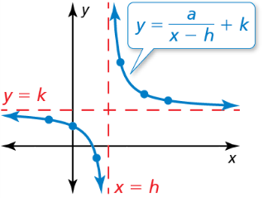

**Your Notes**

**Simplifying Complex Fractions**

Method 1 If necessary, simplify the numerator and denominator by writing each as a single fraction. Then divide by multiplying the numerator by the reciprocal of the denominator.

Method 2 Multiply the numerator and the denominator by the LCD of *every* fraction in the numerator and denominator. Then simplify.

**Inverse Variation**

* Two variables *x* and *y* show inverse variationwhen they are related as follows: *y* = $\frac{a}{x}$, *a* ≠ 0.
* The constant *a* is the constant of variation, and *y* is said to *vary inversely* with *x*.

**Additional Review**

* Writing Inverse Variation Equations,

*p. 361*

* Solving Rational Equations by Cross Multiplying, *p. 392*
* Solving Rational Equations by Using the Least Common Denominator, *p. 393*
* Using Inverses of Functions, *p. 395*

**Adding or Subtracting with Like Denominators**

Let *a*, *b*, and *c* be expressions with *c* ≠ 0.

**Addition Subtraction**

$\frac{a}{c}+\frac{b}{c}=\frac{a+b}{c}$ $\frac{a}{c}-\frac{b}{c}=\frac{a-b}{c}$

**Adding or Subtracting with Unlike Denominators**

Let *a*, *b*, *c*, and *d* be expressions with *c* ≠ 0 and *d* ≠ 0.

**Addition Subtraction**

$\frac{a}{c}+\frac{b}{c}=\frac{ad}{cd}+\frac{bc}{cd}=\frac{ad+bc}{cd}$ $\frac{a}{c}-\frac{b}{d}=\frac{ad}{cd}-\frac{bc}{cd}=\frac{ad-bc}{cd}$

**Simplifying Rational Expressions**

Let *a*, *b*, and *c* be expressions with *b* ≠ 0 and *c* ≠ 0.

Property $\frac{ac}{bc}=\frac{a}{b}$ Divide out common factor *c*.

**Multiplying Rational Expressions**

Let *a*, *b*, *c*, and *d* be expressions with *b* ≠ 0 and *d* ≠ 0.

Property $\frac{a}{b}∙\frac{c}{d}=\frac{ac}{bd}$ Simplify $\frac{ac}{bd}$ if possible.

**Dividing Rational Expressions**

Let *a*, *b*, *c*, and *d* be expressions with *b* ≠ 0, *c* ≠ 0, and *d* ≠ 0.

Property $\frac{a}{b}÷\frac{c}{d}=\frac{a}{b}∙\frac{d}{c}=\frac{ad}{bc}$ Simplify $\frac{ad}{bc}$ if possible.

**Graphing Translations of Simple Rational Functions**

To graph a rational function of the form *y* = $\frac{a}{x-h}$ + *k*, follow these steps:

**Step 1** Draw the asymptotes *x* = *h* and *y* = *k*.

**Step 2** Determine if there has been a reflection to determine where the branches should be.

**Step 3** Draw the two branches of the hyperbola so that they approach the asymptotes.