Algebra 2CP Name _____________________________________

Rational Function Practice Test
Part II – All work on a separate piece of paper.
Given the graph below, answer the following questions:
1.) Domain (interval notation)
2.) Range (interval notation)
3.) Equation for Vertical Asymptote
4.) Equation for Horizontal Asymptote
5.) Increasing interval(s) (interval notation)
6.) Increasing interval(s) (interval notation)
7.) End behavior
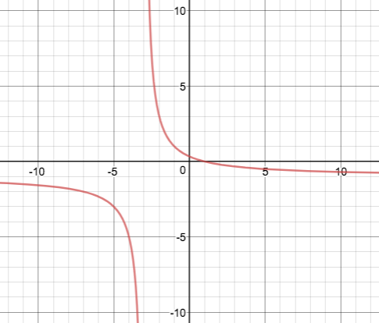
8.) Graph $f\left(x\right)=\frac{1}{x+3}+2$. Draw the asymptotes as dashed lines and label them with their equations.
9.) Graph $f\left(x\right)=\frac{-1}{x-1}+3$. Draw the asymptotes as dashed lines and label them with their equations.
10.) Graph $\left(x\right)=\frac{3x-1}{x+4}$ . Draw the asymptotes as dashed lines and label them with their equations.
11.) Solve: $\frac{4}{x+2}-\frac{1}{6}=\frac{x-1}{x+2}$
12.) Solve: $\frac{4}{x+3}-\frac{7}{x^{2}-9}=\frac{2}{x-3}$
13.) Solve: $\frac{2}{x-3}=\frac{7}{2x-3}$
14.) Mr. Harris can solve the world’s most enjoyable math problem in 4 days. His evil twin brother can solve the same problem in 2 days. How long will it take them to solve the problem if they work together?

