Algebra 2 CP Name _____________________________________
Polynomial Practice Test
Show all work on a separate piece of paper. Check your answers online along the way or when you are finished. For 1-6, no calculators allowed. For 7-11, calculators are allowed if needed.
1.) Prove the following polynomial identity: $\left(x^{2}+3\right)\left(x^{2}-3\right)=x^{4}-9$

2.) Sketch the following polynomial, showing the zeros, x-and y-intercepts, end behavior, and general shape.
$f\left(x\right)=x{(x+2)}^{2}(x-3){(x+5)}^{2}$

3.) For the following polynomial, find: a.) domain and range, b.) absolute min and max, c.) relative min and max, d.) end behavior, e.) lowest possible degree of the polynomial, f.) positive or negative leading coefficient, g.) interval(s) where the function is increasing and decreasing, h.) interval(s) where $f\left(x\right)>0$ and $f\left(x\right)<0$, and i.) a possible polynomial equation for this graph (use the zeros).
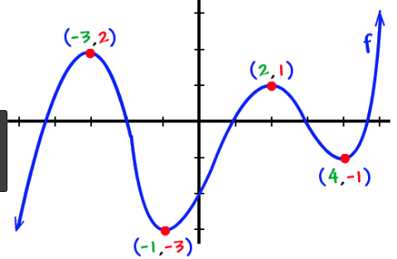

4.) Given $f\left(x\right)=x^{3}-5x^{2}-9x+45$ show that $(x-5)$ is a factor of $f(x)$. Then factor $f\left(x\right)$ completely.

5.) Find all complex solutions, real and imaginary, of $0={4x}^{4}+13x^{2}-12$.

6.) Divide $f\left(x\right)=x^{4}+2x^{2}-x+5$ by $x^{2}-x+1$ using long division.

7.) List all possible rational roots of the function $f\left(x\right)={2x}^{3}+3x^{2}+6x-12$

8.) Find all zeros (real and imaginary) of a polynomial. (Hint: Use your graphing calculator to help you find a real, rational root, then go from there). $f\left(x\right)=x^{3}-3x^{2}+4x-12$

9.) Find all real zeros of $p\left(x\right)=4x^{4}+5x^{3}+2x^{2}-x-6$ in your graphing calculator and tell how many complex zeros there are. Round to 4 decimal places.
10.) The beetle population of a small, remote island can be modeled by the equation
$f\left(t\right)=-0.004t^{5}+75t+1500$ where t is the time in months since observations of the island began, and t=1 represents January.
a. Use your calculator to sketch a graph of the function. Label any intercepts and maxima/minima.
b. During what months was the population increasing? Decreasing? (Use words, not interval notation)
c. During what month did the rabbits have the highest population?
d. What was the highest population?

11.) A farmer has 900 ft of fencing and wants to fence off a rectangular field that borders a straight river. He does not need a fence along the river. What are the dimensions of the field of largest area that he can fence? (see diagram)

X=width | Length | Area
0
100
200
300
400
500
Write equations to model the Length and Area as a function of x. Graph the equation on your calculator. Find the width that will allow the farmer to maximize its area. What is the maximum area?

Length = ___________________ Area = _____________

A width of __________gives a max area of____________.

