Algebra 2 CP Practice Test Name _____________________________________

Date _______________________________________

Unit 2 – Parabola Practice Test
1.) Given the vertex of a parabola is (0,0) and the equation of the directrix is $y=-3$, find the equation for the parabola and sketch a graph labeling the vertex, directrix, and focus and two other points (1 point on each side of vertex)
2.) Given the vertex of a parabola is (0,0) and the focus is (-4,0), find the equation for the parabola and sketch a graph labeling the vertex, directrix, and focus and two other points (1 point on each side of vertex).
3.) Given the vertex of a parabola is (-3,4) and the focus is (-3,2), find the equation for the parabola and sketch a graph labeling the vertex, directrix, and focus and two other points (1 point on each side of vertex).
4.) Given the focus is (2,4) and the equation of the directrix is $y=4$, find the equation for the parabola and sketch a graph labeling the vertex, directrix, and focus and two other points (1 point on each side of vertex).
5.) Using the graph below, find the vertex, focus, directrix, axis of symmetry, and equation.
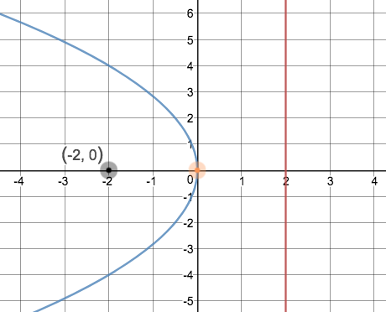
6.) Using the graph below, find the vertex, focus, directrix, axis of symmetry, and equation.
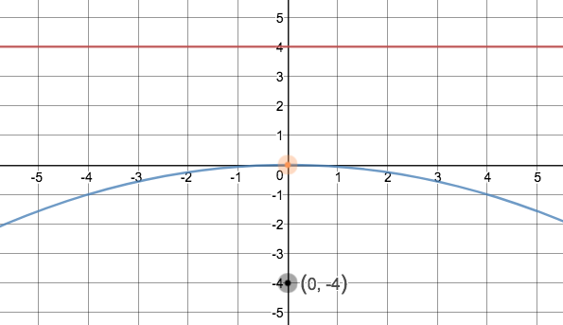
7.) Using the graph below, find the vertex, focus, directrix, axis of symmetry, and equation.
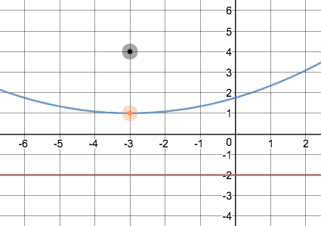
8.) Using the graph below, find the vertex, focus, directrix, axis of symmetry, and equation.
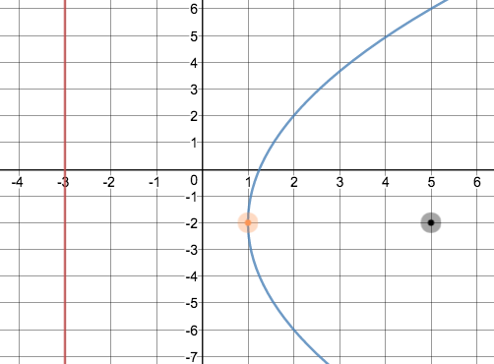

9.) Given $y=-\frac{1}{8}x^{2}$, draw a graph showing the focus, vertex, directrix, and axis of symmetry and 2 other points labeled (1 point on each side of vertex). Label all parts of the graph.
10.) Given $x=-\frac{1}{12}y^{2}$, draw a graph showing the focus, vertex, directrix, and axis of symmetry and 2 other points labeled (1 point on each side of vertex). Label all parts of the graph.
11.) Given $x=-\frac{1}{4}{\left(y+1\right)}^{2}+1$, draw a graph showing the focus, vertex, directrix, and axis of symmetry and 2 other points labeled (1 point on each side of vertex). Label all parts of the graph.
12.) Given $y=-\frac{1}{16}{\left(x-2\right)}^{2}-1$, draw a graph showing the focus, vertex, directrix, and axis of symmetry and 2 other points labeled (1 point on each side of vertex). Label all parts of the graph.
13.) Use the distance formula to write the equation of the parabola below.
14.) Use the distance formula to write the equation of the parabola below.
15.) An archway in front of the Westlake auditorium is in the shape of a parabola. The top of the arch is the vertex (0,0). The school seal is at the focus, 5 feet below the vertex and the arch is 20 feet wide at the ground. Write an equation that represents a cross section of the arch. What is the height from the top of the arch to the ground?
16.) A parabolic microwave antenna is 16 feet in diameter. Write an equation that represents the cross section of the antenna with its vertex at (0,0) and its focus 10 feet to the right of the vertex. What is the depth of the antenna?

