Algebra 2 CP: Unit 1 Transformations with Absolute Value and Quadratic Functions

***Review: YOU CAN (WITHOUT A CALCULATOR)….***

* **GRAPH, IN DETAIL, THE PARENT GRAPHS OF THE ABSOLUTE VALUE AND QUADRATIC FUNCTIONS**

1. Graph 2.Graph $f(x)=x^{2}$

* **GIVEN AN ABSOLUTE VALUE OR QUADRATIC FUNCTION, IDENTIFY THE PARENT FUNCTION, DESCRIBE THE TRANSFORMATIONS, AND GRAPH THE FUNCTION**

For the #3-14, a) identify the parent function b) describe the transformation(s), and c) graph.

3.  4. 5.  6. 

7.  8.  9.  **10**. 

11.  12.  13. 14. $h\left(x\right)=-2\left|x-3\right|+2$

* **GIVEN AN ABSOLUTE VALUE OR QUADRATIC GRAPH, IDENTIFY THE PARENT FUNCTION, DESCRIBE THE TRANSFORMATIONS, AND WRITE AN EQUATION FOR A GRAPH**

For #15-25. Identify the parent function. Describe the transformations. Write an equation for the graph.

15. 16. 17.

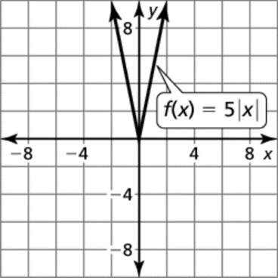

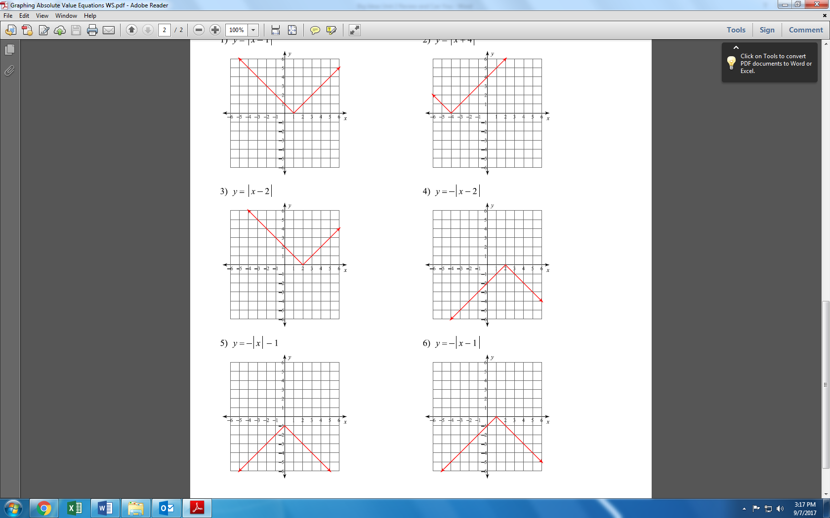

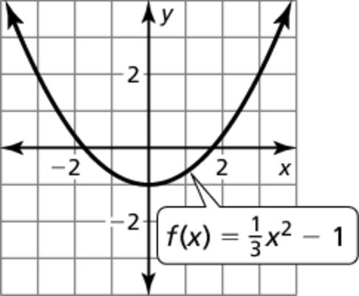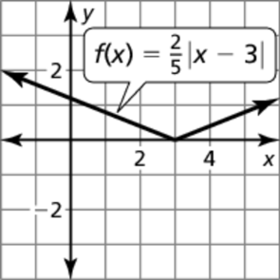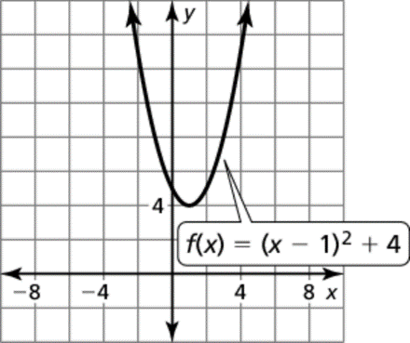

18. 19.

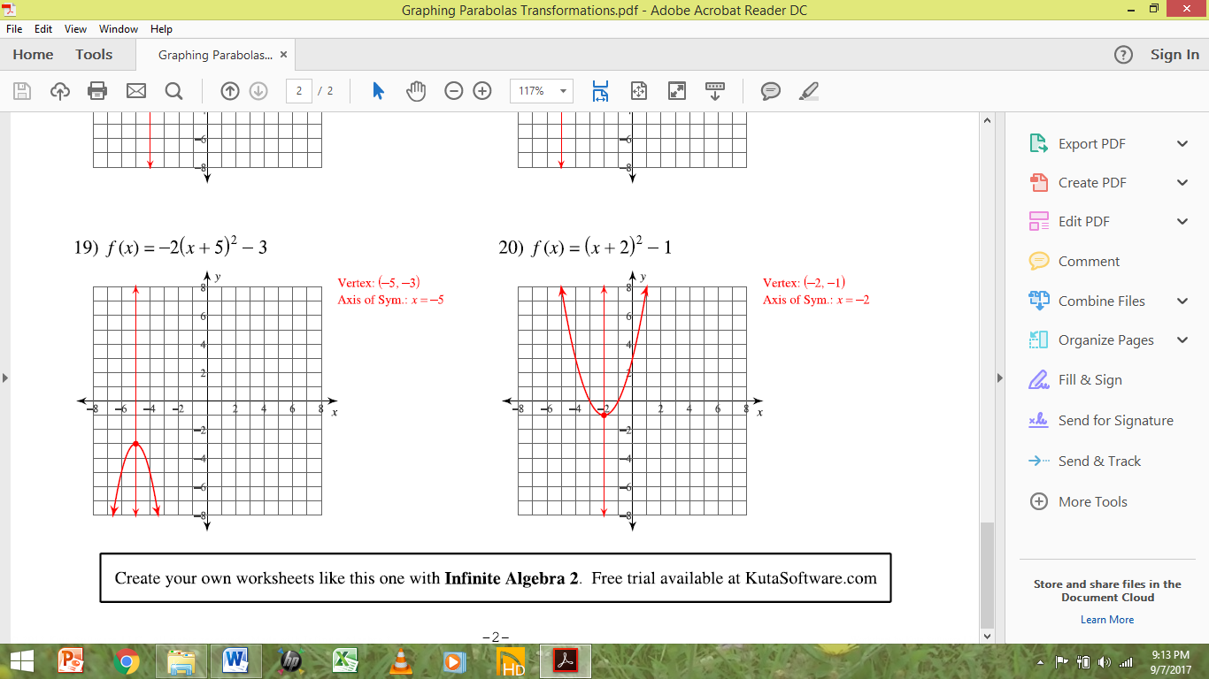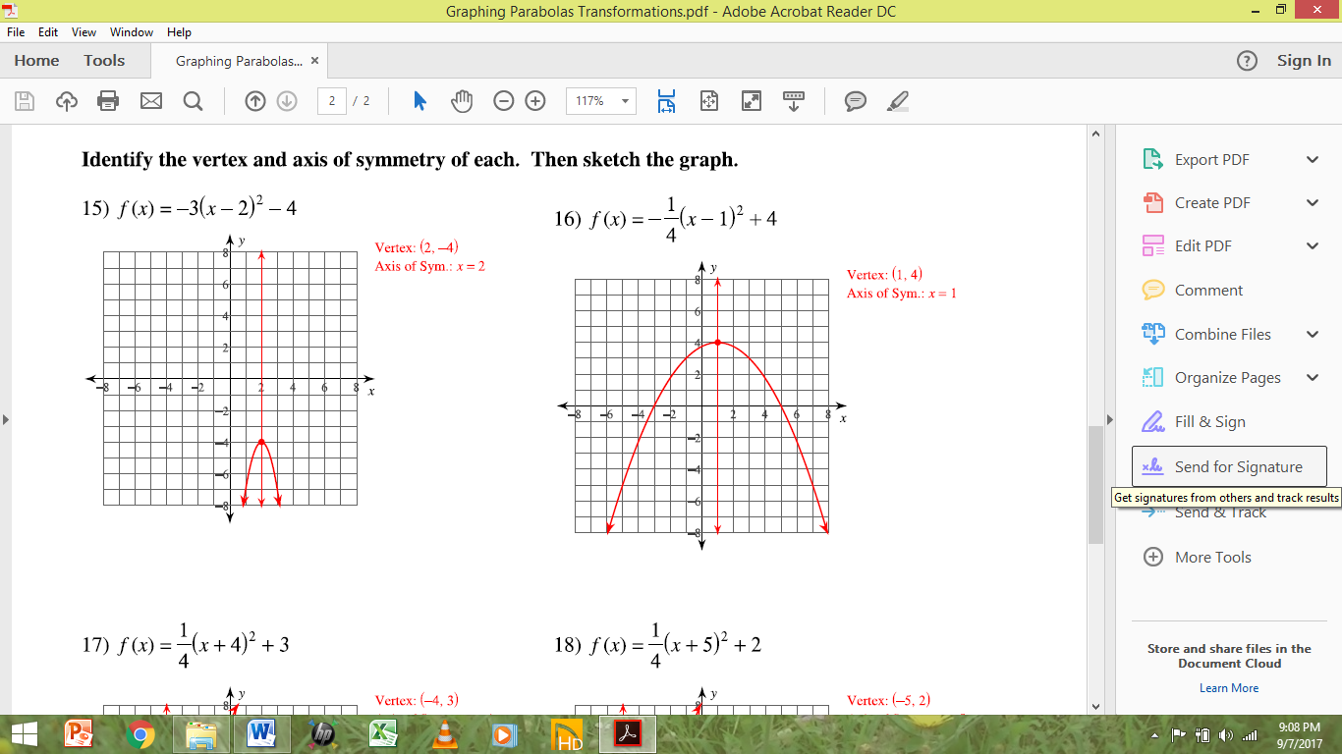20. 21. 22.

23. 24. 25.

* **GIVEN A NON-PARENT ABSOLUTE VALUE FUNCTION AND TRANSFORMATIONS, CREATE A NEW FUNCTION**

For #26-30, write a function *g* whose graph represents the indicated transformation of the graph of *f*.

26.  translation 3 units down 27. reflection in the *x*-axis

28.  translation 2 units left 29. translation 2 units up

30. vertical stretch by a factor of 2

* **DESCRIBE THE CHARACTERISTICS OF QUADRATIC FUNCTIONS INCLUDING DOMAIN AND RANGE, AXIS OF SYMMETRY (AOS), INTERCEPTS, INTERVALS OF INCREASING AND DECREASING, AND END BEHAVIOR. BE ABLE TO DO THIS IN FOR A REAL-LIFE APPLICATION. Use appropriate notation as demonstrated in class.**

Return to #20 and 23 and identify the domain and range, equation of the axis of symmetry, intercepts, intervals of increasing and decreasing, and end behavior; Review WS 5

***HAVE YOU:***

**\* Reviewed your notes (read through all problems, redo problems you are not completely comfortable with, and practice the vocabulary)**

**\* Redone homework problems and practiced additional problems**

**\*Come in for additional help if needed (Math Center and/or your teacher office hours)**

**\* Investigated the online resources at the Big Ideas Math website?**