Name Date

Practice A

10.1

In Exercises 1 and 2, find the number of possible outcomes in the sample space. Then list the possible outcomes.

1. You roll three dice.

2. A clown has three purple balloons labeled a, b, and c, three yellow balloons labeled a, b, and c, and three turquoise balloons labeled a, b, and c. The clown chooses a balloon at random.

3. Your friend has eight sweatshirts. Three sweatshirts are green, one is white, and four are blue. You forgot your sweatshirt, so your friend is going to bring one for you as well as one for himself. What is the probability that your friend will bring two blue sweatshirts?

4. The estimated percentage student GPA distribution is shown. Find the probability of each event.

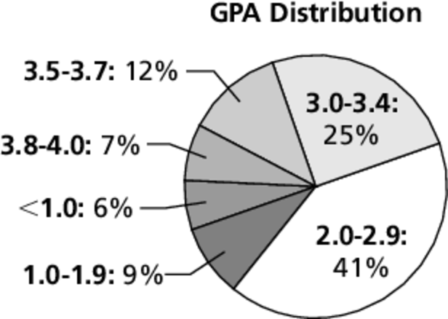

a. A student chosen at random has GPA of at least 3.0.

b. A student chosen at random has GPA between 1.0 and 2.9, inclusive.

5. A bag contains the same number of each of four different colors of marbles.   
A marble is drawn, its color is recorded, and then the marble is placed back   
in the bag. This process is repeated until 40 marbles have been drawn. The   
table shows the results. For which marble is the experimental probability of drawing the marble the same as the theoretical probability?

|  |  |  |  |
| --- | --- | --- | --- |
| Drawing Results | | | |
| yellow | red | blue | black |
| 12 | 10 | 7 | 11 |

Name Date

Practice B

10.1

In Exercises 1 and 2, find the number of possible outcomes in the sample space. Then list the possible outcomes.

1. You roll a die and draw a token at random from a bag containing three pink   
tokens and one red token.

2. You draw 3 marbles without replacement from a bag containing two brown marbles and three yellow marbles.

3. When two six-sided dice are rolled, there are 36 possible outcomes.

a. Find the probability that the sum is 5.

b. Find the probability that the sum is not 5.

c. Find the probability that the sum is less than or equal to 5.

d. Find the probability that the sum is less than 5.

4. A tire is hung from a tree. The outside diameter is 34 inches and the inside diameter is 14 inches. You throw a baseball toward the opening of the tire.   
Your baseball is equally likely to hit any point on the tire or in the opening   
of the tire. What is the probability that you will throw the baseball through   
the opening in the tire?

In Exercises 5–7, tell whether the statement is *always*, *sometimes*, or *never* true. Explain your reasoning.

5. If there are exactly five possible outcomes and all outcomes are equally likely, then the theoretical probability of any of the five outcomes occurring is 0.20.

6. The experimental probability of an event occurring is equal to the theoretical probability of an event occurring.

7. The probability of an event added to the probability of the complement of the event is equal to 1.

8. A manufacturer tests 900 dishwashers and finds that 24 of them are defective. Find the probability that a dishwasher chosen at random has a defect. An apartment building orders 40 of the dishwashers. Predict the number of dishwashers in the apartment with defects.